Creating Azure SQL Database and Virtual Machine

Step 1: Create a Resource Group
- Login to Microsoft Azure Portal.
- In the search bar, select Resource Groups.
- Click on Create.
- Enter the following details:
  - Subscription: Azure for Students
  - Resource Group Name: GL-SQL-RG
  - Region: (Asia Pacific) Central India
- Click Review + Create.
- Click Create.
Resource Group created successfully.
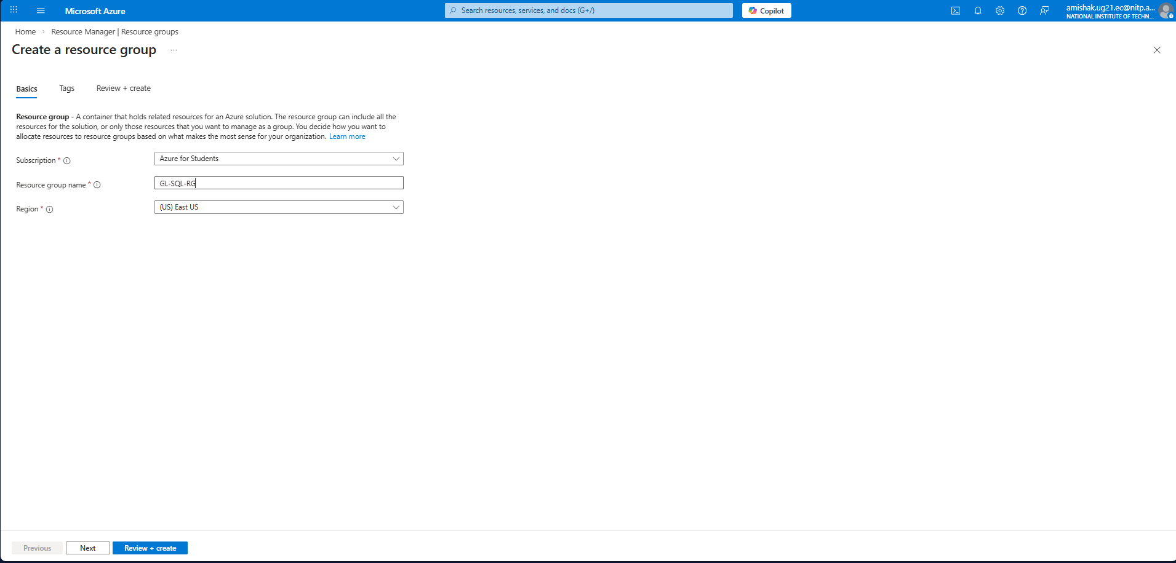

Step 2: Create SQL Server (Logical Server)
- Go to Azure SQL → SQL logical servers.
- Click Create SQL Database Server.
- Under Project Details:
  - Subscription: Azure for Students
  - Resource Group: GL-SQL-RG
- Under Server Details:
  - Server Name: glsqlserver04
  - Location: (Asia Pacific) Central India
  - Authentication Type: SQL Authentication
  - Set Admin Username and Password
- Click Review + Create
- Click Create
SQL Logical Server created successfully.
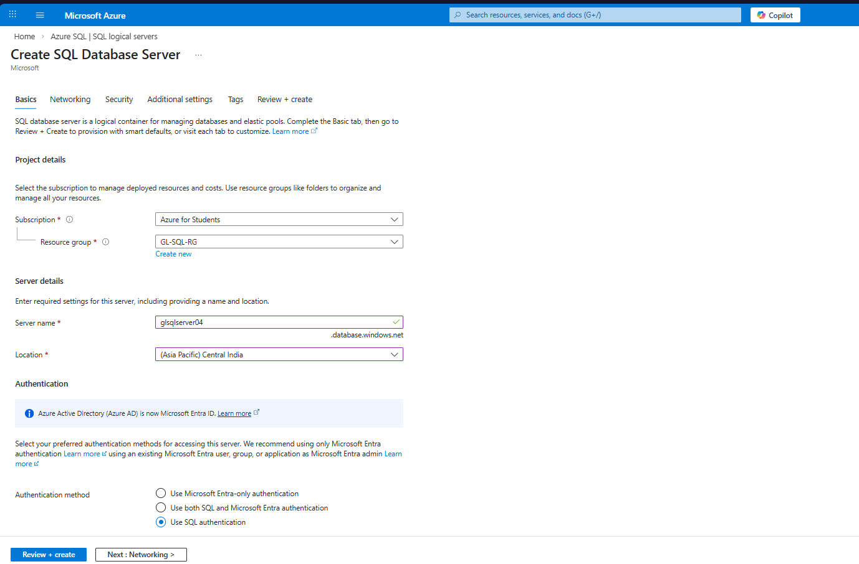

Step 3: Create SQL Database
- Go to Azure SQL → SQL Databases.
- Click Create Database.
- Enter the following:
  - Database Name: SampleDB
  - Server: glsqlserver04
  - Compute + Storage: General Purpose (Default)
- Click Review + Create
- Click Create
Database created successfully under the server.
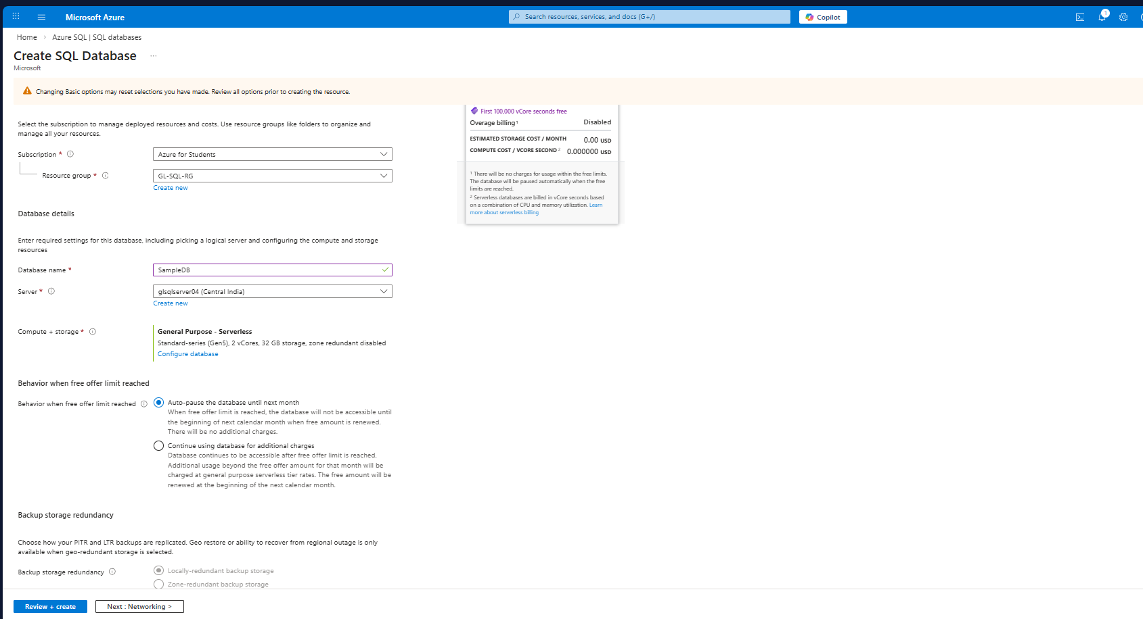

Step 4: Configure Firewall and Network Access
- Open the created database.
- Click on Set server firewall.
- Add your Client IP Address.
- Click Save.
Network access configured.

Step 5: Connect Using Query Editor
- Open Query Editor (Preview).
- Login using SQL Authentication.
- Run the following sample query:
SELECT * FROM [Sales].[Customer];
- Click Run.
Query executed successfully and results displayed.
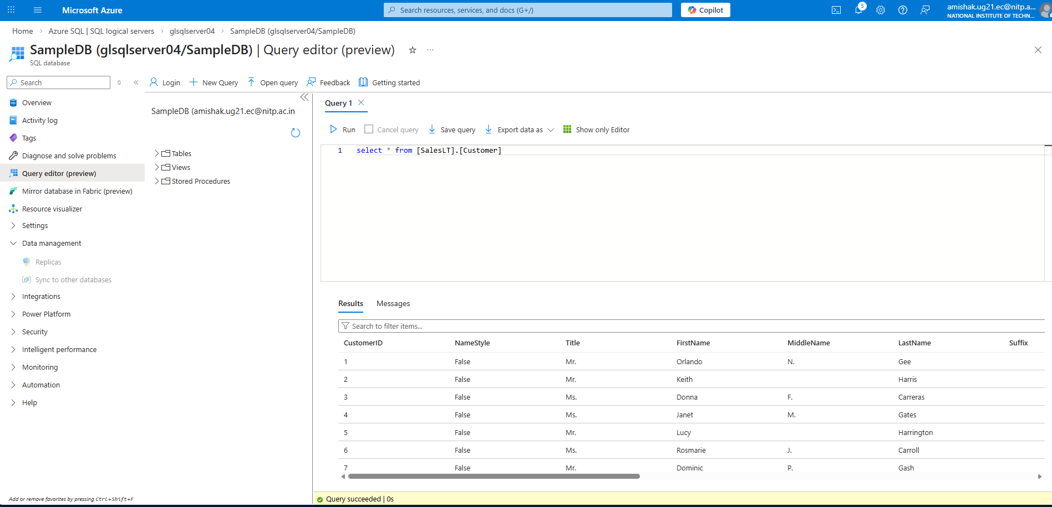

Step 6: Create a Virtual Machine
- Go to Compute → Virtual Machines.
- Click Create → Virtual Machine.
- Under Project Details:
  - Subscription: Azure for Students
  - Resource Group: GL-SQL-RG
- Under Instance Details:
  - Virtual Machine Name: GL-SQL-VM
  - Region: Central India
  - Availability Zone: Zone 1
  - Image: Windows 10
  - Size: Standard D2s v3 (Default)
- Configure Administrator Username and Password.
- Click Review + Create.
- Click Create.
Virtual Machine deployed successfully.
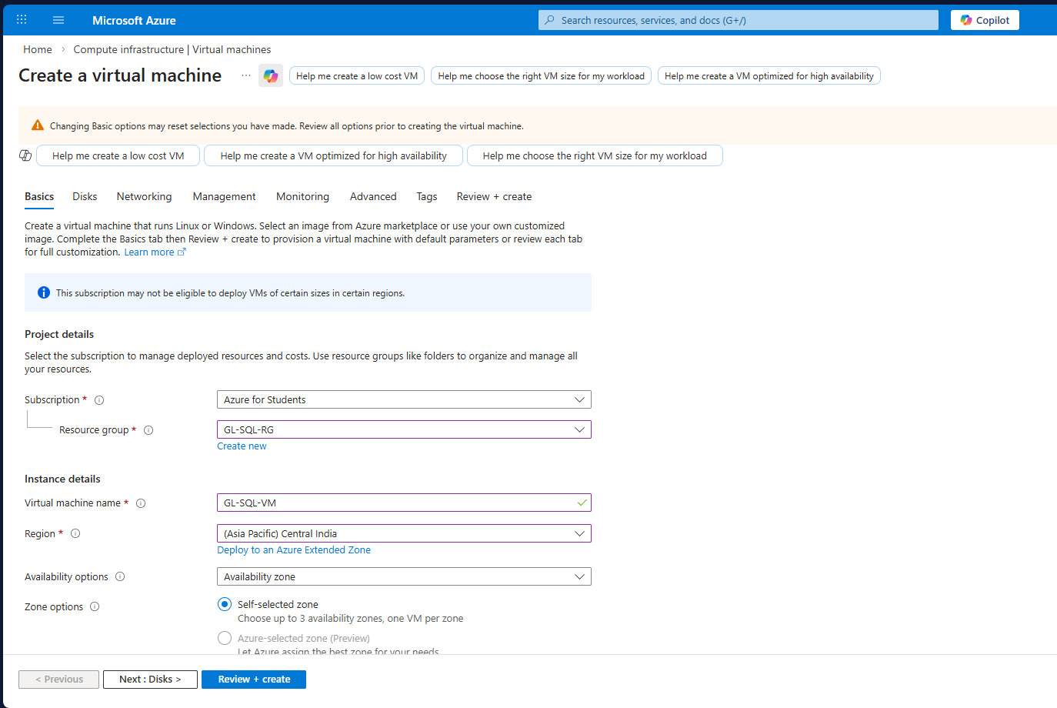

Step 7: Connect to Virtual Machine
- Open the VM.
- Click Connect → RDP.
- Download and open RDP file.
- Enter credentials.
- Successfully logged into Windows VM.

Step 8: Install Azure Data Studio
- Inside the VM, opened browser.
- Search for Azure Data Studio.
- Downloaded and installed.
- Launched Azure Data Studio.

Step 9: Connect to SQL Database from VM
- Open Azure Data Studio.
- Click New Connection.
- Enter:
  - Server: glsqlserver04.database.windows.net
  - Authentication Type: SQL Login
  - Username & Password
  - Database: SampleDB
- Click Connect.
Successfully connected to database.
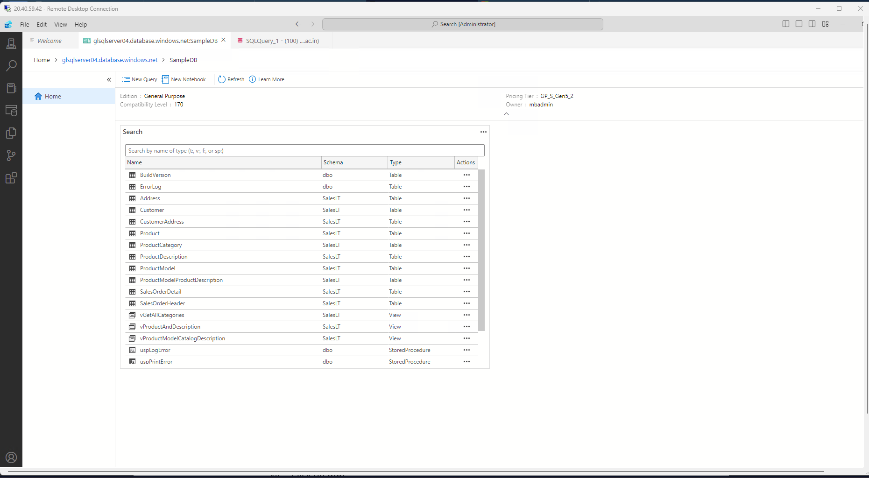

Step 10: Run Query in Azure Data Studio
Run the following query:
SELECT * FROM Sales.Customer;
Results are displayed successfully.
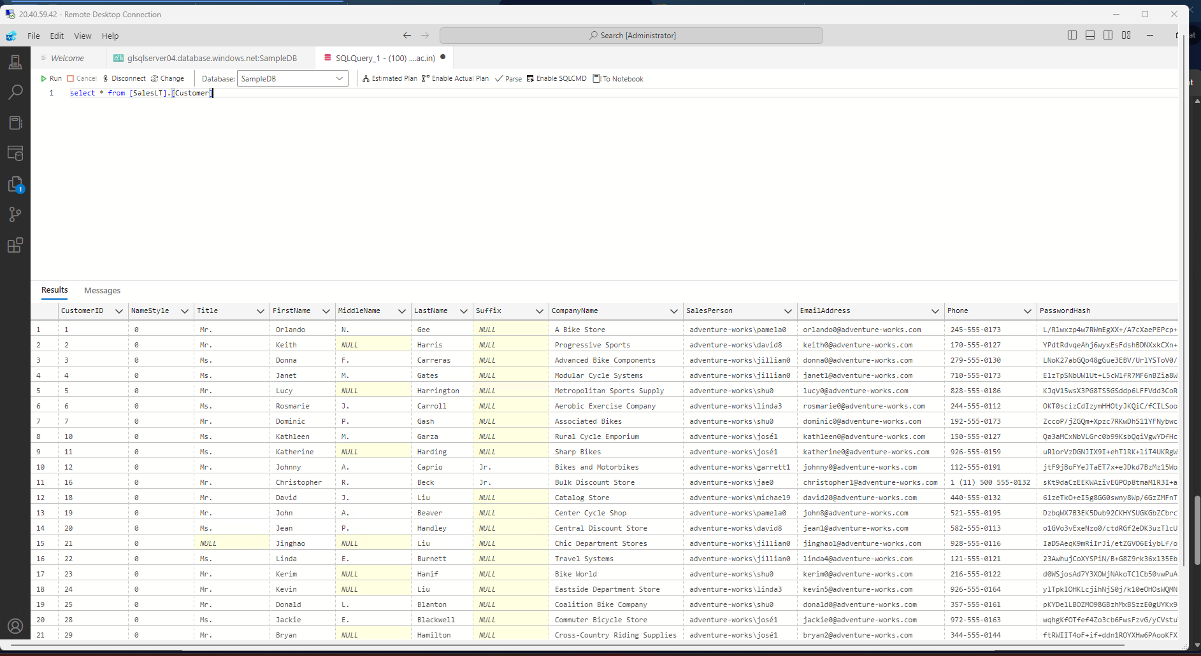

Services Used
- Azure SQL Database
- Azure Virtual Machines
- Azure Resource Manager
- Azure Data Studio

Conclusion
In this exercise, we successfully:
- Created a Resource Group
- Created SQL Logical Server
- Created SQL Database
- Configured Firewall
- Created a Virtual Machine
- Installed Azure Data Studio
- Connected and executed SQL queries

